**SDLC --> MULTI-CHANNEL ADC**

**SUBMISSION B**

**LINKS FOR FUTURE REFERENCE:**

<https://www.ni.com/docs/en-US/bundle/labview/page/lvhowto/graphing_digital_data.html>

**DESIGN**

1. **WIREFRAMING:**

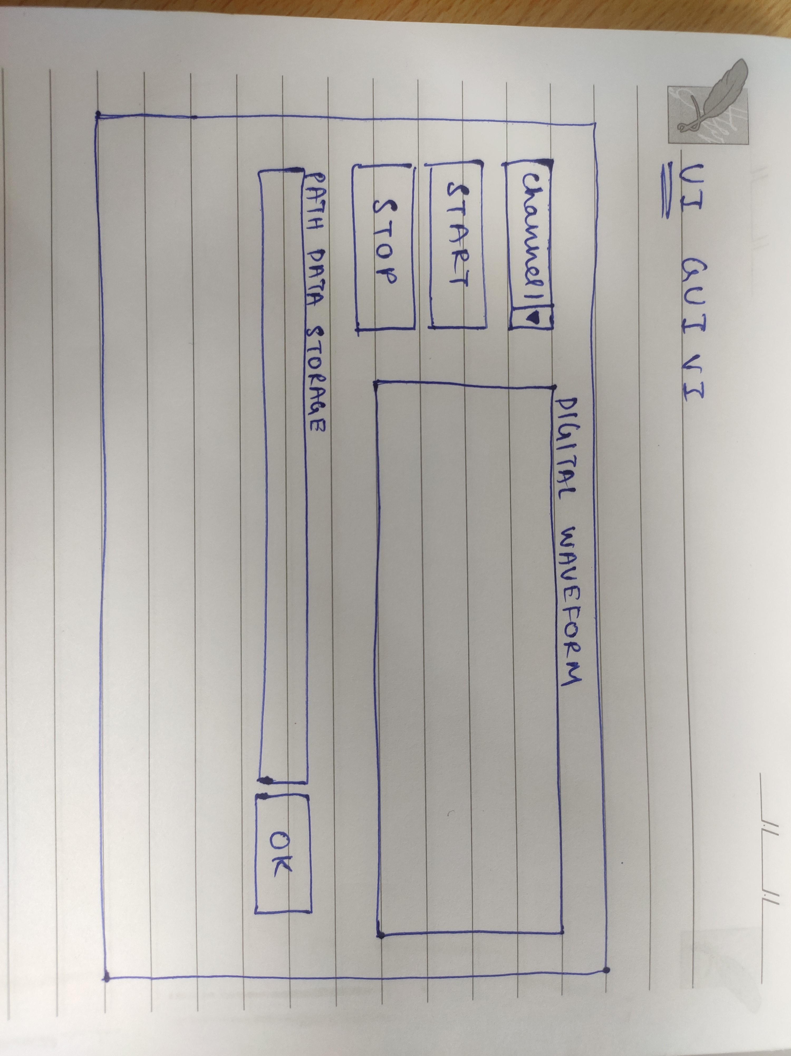

This is the wireframe created for GUI. Here I have added the channel selection Enum, START and STOP Boolean buttons, output digital waveform display, path selection for the data storage file.

1. **COLOR PALETTE:**

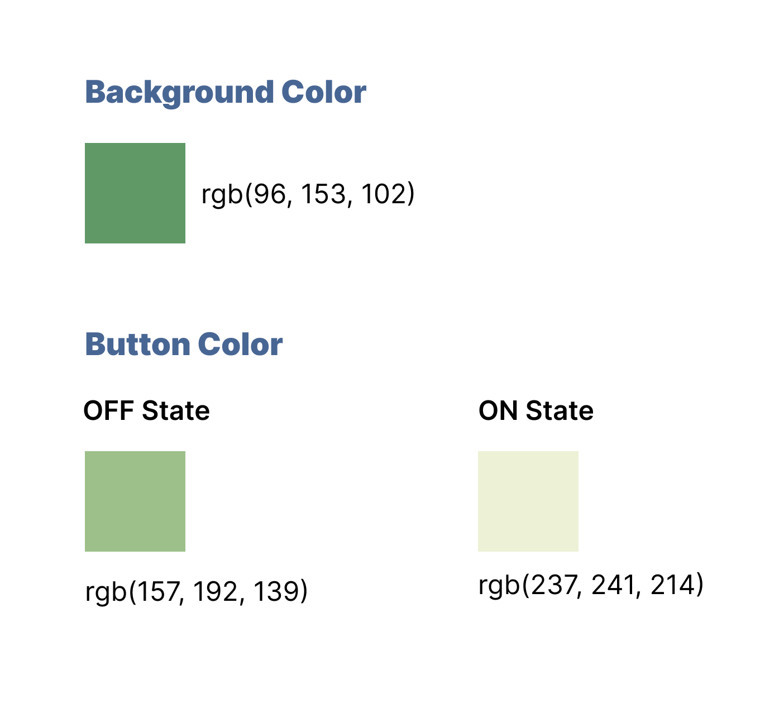

These are the colors that were chosen for the GUI VI. The RGB values are also given. This color was chosen to give a feel of real time machines such as CRO etc... to resemble such looks.

1. **MOCKUP:**

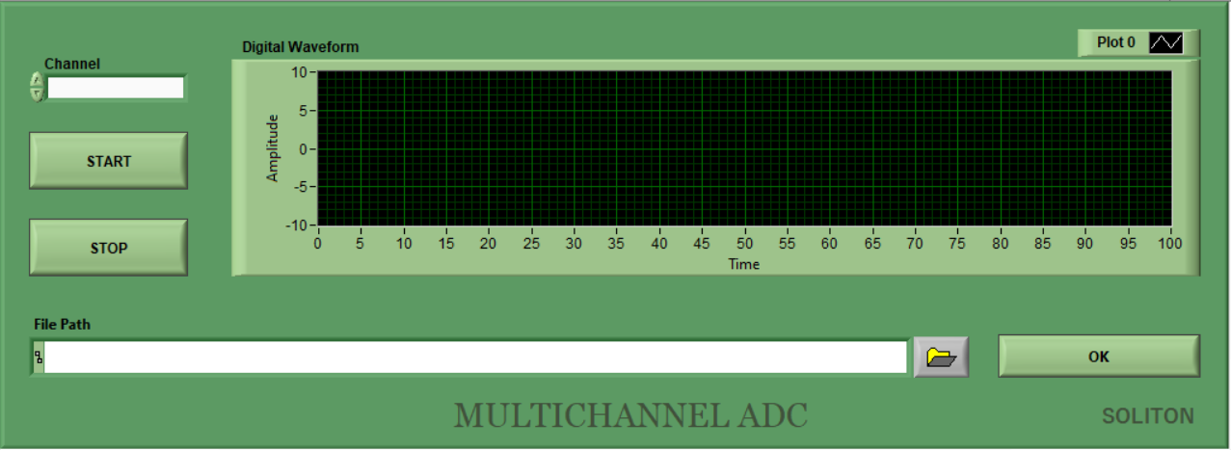

**Update 1:**

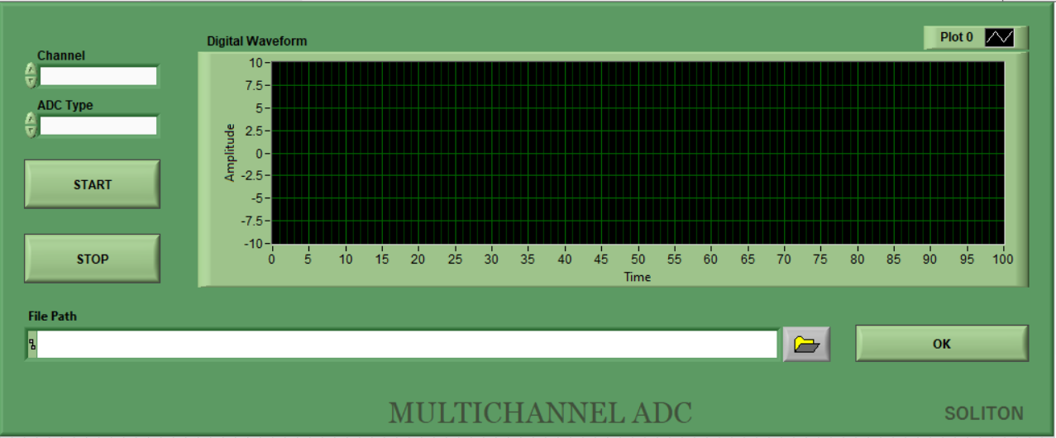

These are the mockups created in LabVIEW. Added ADC Type Enum to choose the respective ADC. The ADC specifications will be written in a file and those names are added to this Enum ADC.

**Controls and Indicators Used:**

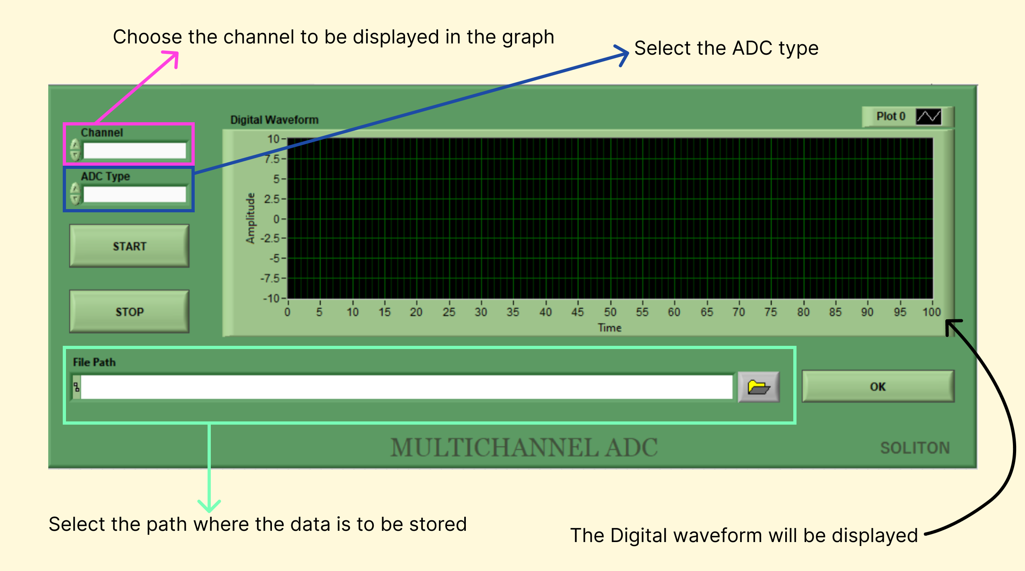

These were the controls that were added to the GUI VI. The channel to be displayed can be chosen, default will be ALL where all the channels value will be displayed. If a particular channel is needed, then that can be chosen from the Enum.

The ADC types are present in the Enum. The user can select the particular ADC needed.

START and STOP will start and stop the data acquisition respectively.

The file in which the data is to be stored can be selected in the file path.

The analog data converted to digital in the ADC driver will be sent to the GUI and will be plotted in the graph.

**Update 2:**

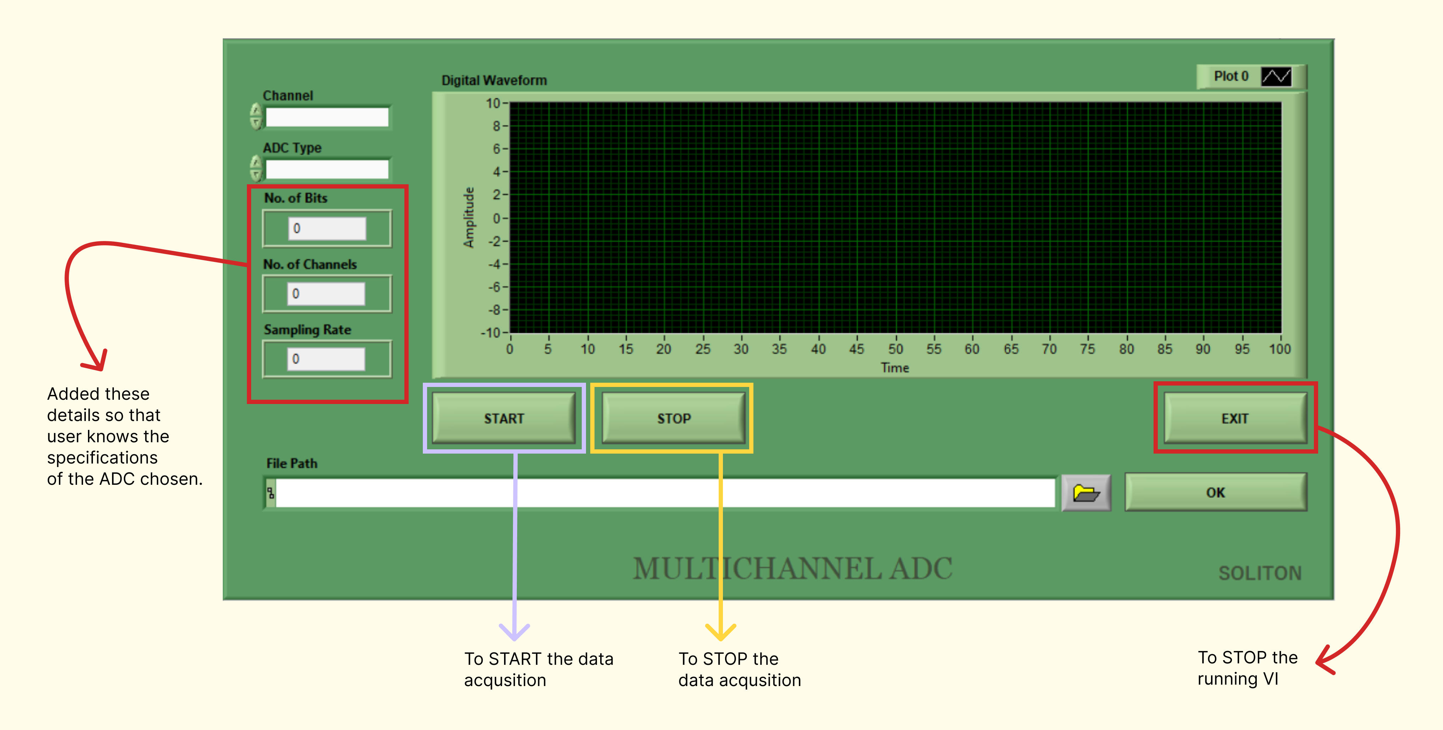

When an ADC is chosen the corresponding bits, channels and sampling rate will be displayed in the indicator. This was added so that the users can get the idea of the ADC that was chosen.

EXIT button was added so that PANEL CLOSE or this button will STOP the VI from running.

**Final Mockup:**

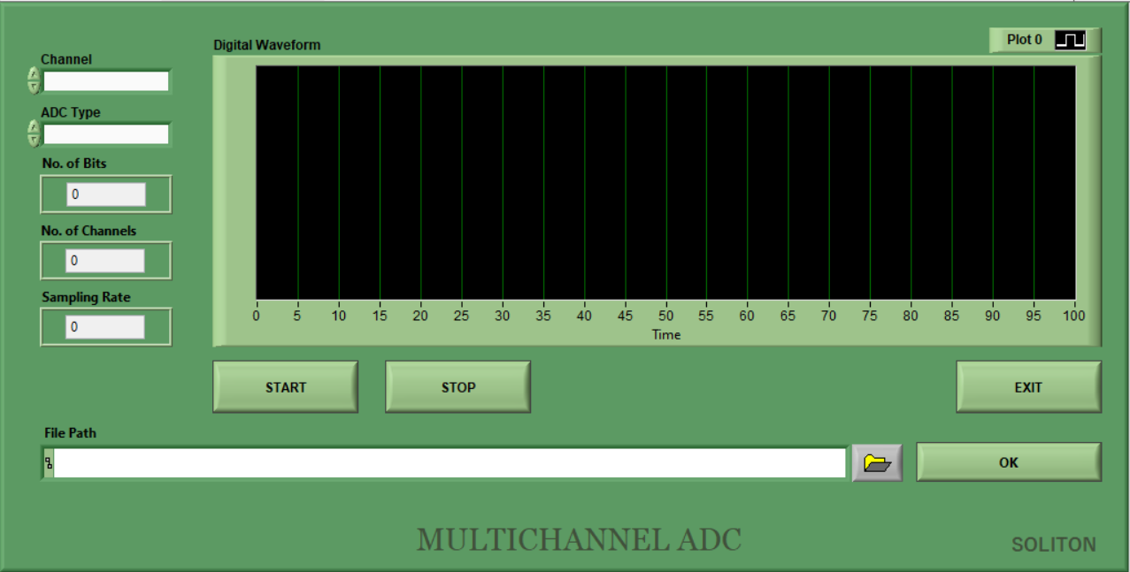

This is the final look of the GUI’s mockup. The graph was replaced with a digital waveform graph to show that digital data will be displayed.

**FLOW OF THE SOLUTION TO BE IMPLEMENTED**

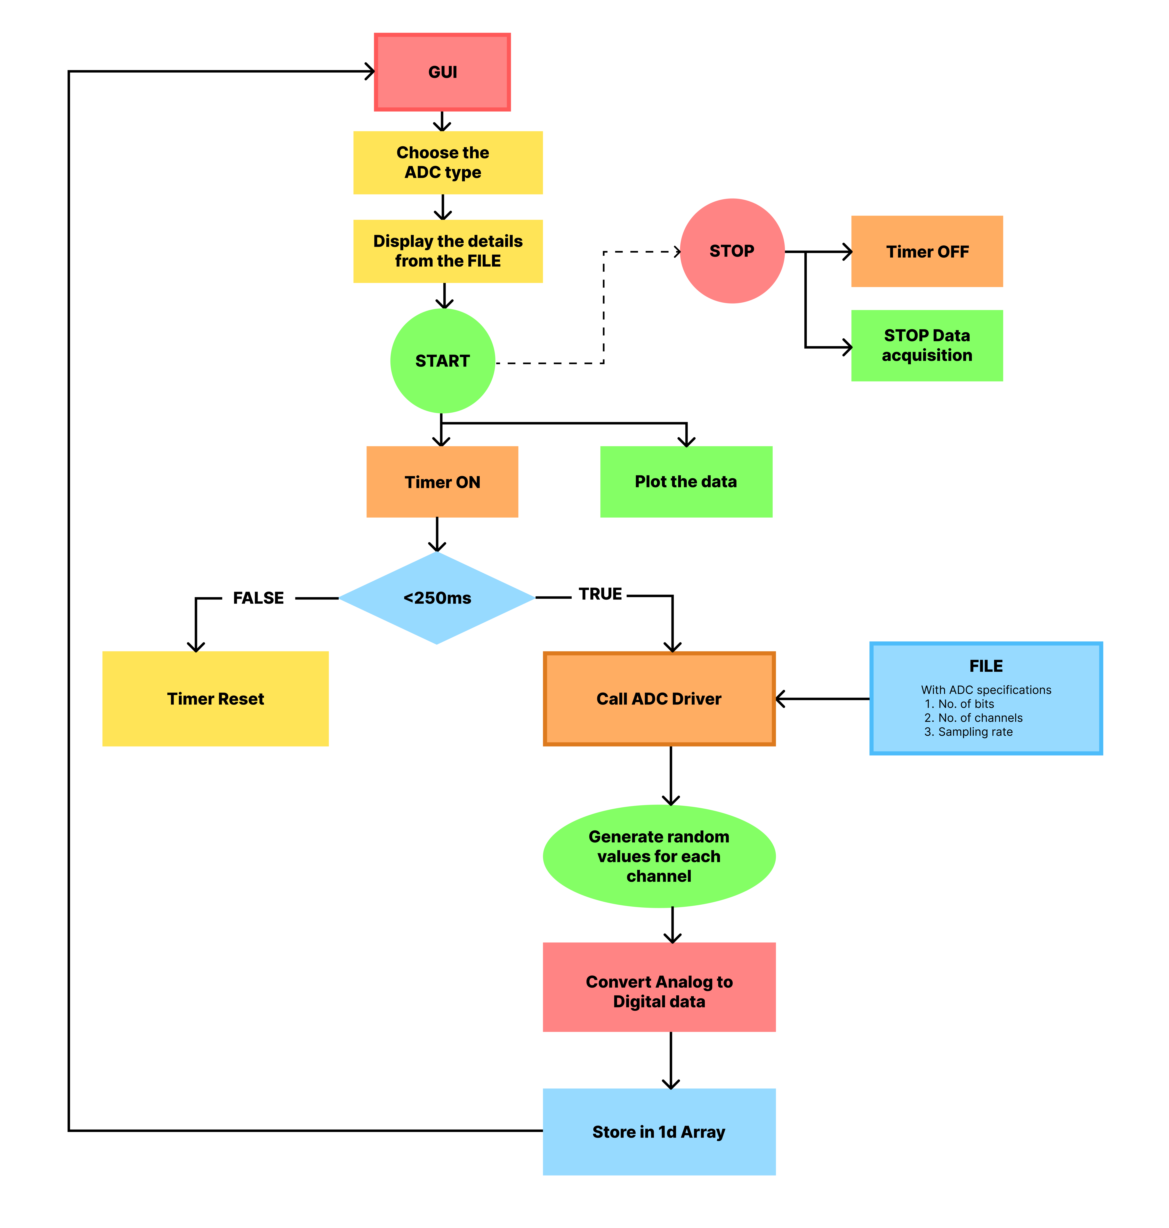

The above flowchart is the rough idea of how the process will take place. Here I have jotted down a rough sketch of the process and tried to break the problem and created the flow with some basic understanding of the problem statement given.

This flowchart will show an overview of approaching the problem.

**VIs CREATED TO EXPLORE PRIMARY FUNCTIONS:**

[SDLC](https://solitontech-my.sharepoint.com/:f:/p/sadhana_suresh/EsfROoLR3BlGsA3FxXNJ0UEB5_aI2Ce8xs9XxV9jdDm2cA?e=l0a9mb) --> OneDrive link

**OTHER LINKS:**

<https://www.figma.com/file/dX6P9gdoAnAiEP89Nee8yZ/SDLC?node-id=0%3A1&t=wSs3oAJvkw0UAD1r-1>

Repo Link: https://192.168.0.181:1100/svn/LVTIPS/trunk/LVTIPS2023B2/SDLC/Sadhana/SUBMISSION B